**Example No 1:**

**Solution:**

using System;

namespace CP_Lab_09

{

class Program

{

static void Main(string[] args)

{

int m = 5;

int n = 4;

string[,] profile = new string[m, n];

profile[0, 0] = " Name |";

profile[0, 1] = "Phone|";

profile[0, 2] = "Designation|";

profile[0, 3] = "Department|";

for (int i = 1; i < m; i++)

{

for (int j = 0; j < n; j++)

{

if (j == 0)

{

Console.WriteLine("Name : ");

profile[i, j] = Console.ReadLine();

}

else if (j == 1)

{

Console.WriteLine("Phone : ");

profile[i, j] = Console.ReadLine();

}

else if (j == 2)

{

Console.WriteLine("Designation : ");

profile[i, j] = Console.ReadLine();

}

else if (j == 3)

{

Console.WriteLine("Department : ");

profile[i, j] = Console.ReadLine();

}

}

Console.WriteLine("Enter Profile{0}", i + 1);

}

Console.Clear();

Console.WriteLine("+++++++++++++++++++PROFILE+++++++++++++++++++++");

for (int i = 0; i < m; i++)

{

for (int j = 0; j < n; j++)

{

Console.Write(" {0} ", profile[i, j]);

}

Console.WriteLine();

}

}

}

}

**Output:**

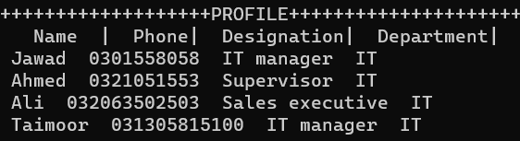

**Task No. 1:** Enter the first matrix and then display it. Secondly, enter the second matrix and then display it. In the result by apply 2D arrays show multiplication of 2 matrixes.

**Solution:**

using System;

namespace ConsoleApp58

{

class Program

{

static void Main(string[] args)

{

Console.WriteLine("Enter no of rows of Matrix 1");

int R1 = int.Parse(Console.ReadLine());

Console.WriteLine("Enter no of columns of Matrix 1");

int C1 = int.Parse(Console.ReadLine());

int[,] mat1 = new int[R1, C1];

Console.WriteLine("Enter elements of matrix 1 row by row");

for (int i = 0; i < R1; i++)

{

for (int j = 0; j < C1; j++)

{

mat1[i, j] = int.Parse(Console.ReadLine());

}

}

Console.WriteLine("Enter no of rows of Matrix 2");

int R2 = int.Parse(Console.ReadLine());

Console.WriteLine("Enter no of columns of Matrix 2");

int C2 = int.Parse(Console.ReadLine());

int[,] mat2 = new int[R2, C2];

Console.WriteLine("Enter elements of matrix 1 row by row");

for (int i = 0; i < R2; i++)

{

for (int j = 0; j < C2; j++)

{

mat2[i, j] = int.Parse(Console.ReadLine());

}

}

Console.WriteLine("Matrix 1 =");

for (int i = 0; i < R1; i++)

{

for (int j = 0; j < C1; j++)

{

Console.Write("{0,4}", mat1[i, j]);

}

Console.WriteLine();

}

Console.WriteLine("Matrix 2 =");

for (int i = 0; i < R2; i++)

{

for (int j = 0; j < C2; j++)

{

Console.Write("{0,4}", mat2[i, j]);

}

Console.WriteLine();

}

if (C1 == R2)

{

int[,] mat3 = new int[R1, C2];

for (int i = 0; i < R1; i++)

{

for (int j = 0; j <C2; j++)

{

mat3[i, j] = 0;

for (int k = 0; k < C1; k++)

{

mat3[i, j] = mat3[i, j] + mat1[i, k] * mat2[k, j];

}

}

}

Console.WriteLine("Matrix 1 x Matrix 2 = ");

for (int i = 0; i < R1; i++)

{

for (int j = 0; j < C2; j++)

{

Console.Write("{0,4}", mat3[i, j]);

}

Console.WriteLine();

}

}

else

{

Console.WriteLine("Multiplication is not possible");

}

}

}

}

**Output:**

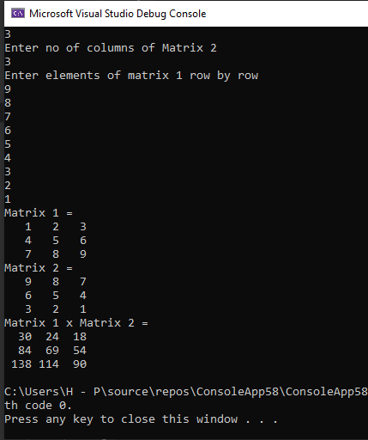

**Task No. 2:** Take N number of user data input and make sure N is greater then 10, which contain name of the user, his/her nationality and his/her eye color. You have to show the max color of eye in each country.

**Solution:**

using System;

namespace CP_Lab_09

{

class Program

{

static void Main(string[] args)

{

Console.WriteLine("Enter number of users");

int N = int.Parse(Console.ReadLine());

int C = 3;

string[,] a = new string[N, C];

a[0, 0] = "Name";

a[0, 1] = "Nationality";

a[0, 2] = "Eye Color";

int brown = 0, green = 0, black = 0, grey = 0, blue = 0;

for (int i = 0; i < N; i++)

{

for (int j = 0; j < C; j++)

{

if (i != 0 && j == 0)

{

Console.WriteLine("Enter Name {0}", i);

a[i, j] = Console.ReadLine();

}

if (i != 0 && j == 1)

{

Console.WriteLine("Enter Nationality {0}", i);

a[i, j] = Console.ReadLine();

}

if (i != 0 && j == 2)

{

Console.WriteLine("Enter EyeColor {0}", i);

a[i, j] = Console.ReadLine();

if (a[i, j] == "Brown" || a[i, j] == "brown")

{

brown++;

}

if (a[i, j] == "Green" || a[i, j] == "green")

{

green++;

}

if (a[i, j] == "Black" || a[i, j] == "black")

{

black++;

}

if (a[i, j] == "Grey" || a[i, j] == "grey")

{

grey++;

}

if (a[i, j] == "Blue" || a[i, j] == "blue")

{

blue++;

}

}

}

}

Console.Clear();

for (int i = 0; i < N; i++)

{

for (int j = 0; j < C; j++)

{

Console.Write("{0,16} ", a[i, j]);

}

Console.WriteLine();

}

Console.WriteLine("Total Brown eyes = {0}",brown);

Console.WriteLine("Total Green eyes = {0}",green);

Console.WriteLine("Total Black eyes = {0}",black);

Console.WriteLine("Total Grey eyes = {0}",grey);

Console.WriteLine("Total Blue eyes = {0}",blue);

}

}

}

**Output:**

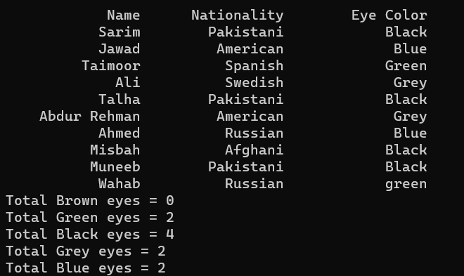

**Task No. 3:** Make a program in C# in which take no. of items, price of items, quantity of items and name of items as input from the user and give the discount according to the following conditions (Use 2D Array):

a. If from Bahria University give discount of 30%.

b. Else if the total amount is greater than 50,000 and less than 100,000 give discount of 20%.

c. Else if the total amount is greater than 100,000 give discount of 30%.

**Solution:**

using System;

namespace CP_Lab_09

{

class Program

{

static void Main(string[] args)

{

int n, total = 0;

double d = 1, dtotal = 0;

Console.WriteLine("Enter No. of items:");

n = int.Parse(Console.ReadLine());

string[,] item = new string[n, 3];

for (int x = 0; x < n; x++)

{

Console.WriteLine("\nEnter name of item {0}:", x + 1);

item[x, 0] = Console.ReadLine();

if (item[x, 0] == "rice" || item[x, 0] == "Rice")

{

d = 0.7;

}

Console.WriteLine("\nEnter price of {0} :", item[x, 0]);

item[x, 1] = Console.ReadLine();

Console.WriteLine("\nEnter quantity of {0} :", item[x, 0]);

item[x, 2] = Console.ReadLine();

total += (int.Parse(item[x, 1]) * int.Parse(item[x, 2]));

}

if (d != 0.7)

{

if (total >= 50000 & total <= 100000)

{

d = 0.8;

}

else if (total > 100000)

{

d = 0.7;

}

}

dtotal = total * d;

Console.WriteLine("S.no\t\tItem name\tPrice\t\tQuantity\n");

for (int x = 0; x < n; x++)

{

Console.Write("{0}", x + 1);

for (int y = 0; y < 3; y++)

{

if (y == 1)

{

Console.Write("\t\t${0}", item[x, y]);

}

else

{

Console.Write("\t\t" + item[x, y]);

}

}

Console.WriteLine();

}

Console.WriteLine("\n\tTotal : {0:c}", total);

if (d != 1)

{

Console.WriteLine("\n\tTotal after discount of {0:0.00}% is : {1:c}", (1 - d) * 100, dtotal);

}

}

}

}

**Output:**

